**Custom Google reviews widget plugin for Elementor**

**Elementor installed required**

Desktop view



Tablet view



Tablet view on less screens



Mobile view



Purpose: Avoid using Google resources to make impacts on site performance and increase Google page speed score

When using Google Review, the score was 36

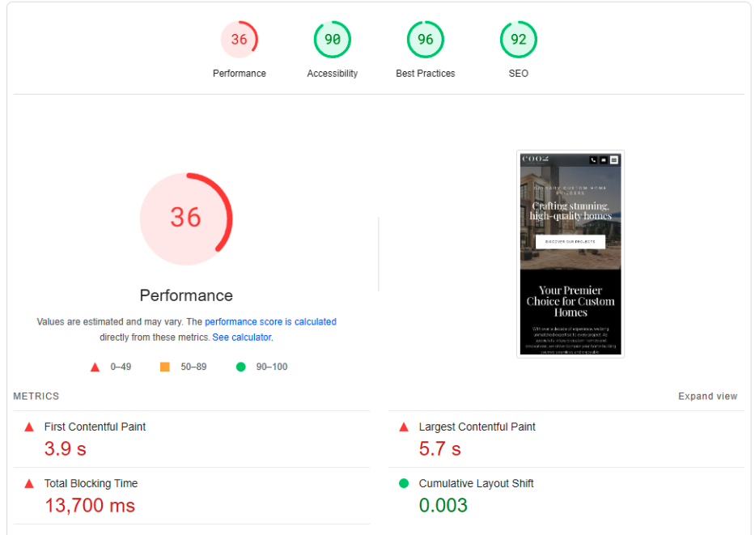

When using a custom Google Review instead of the original

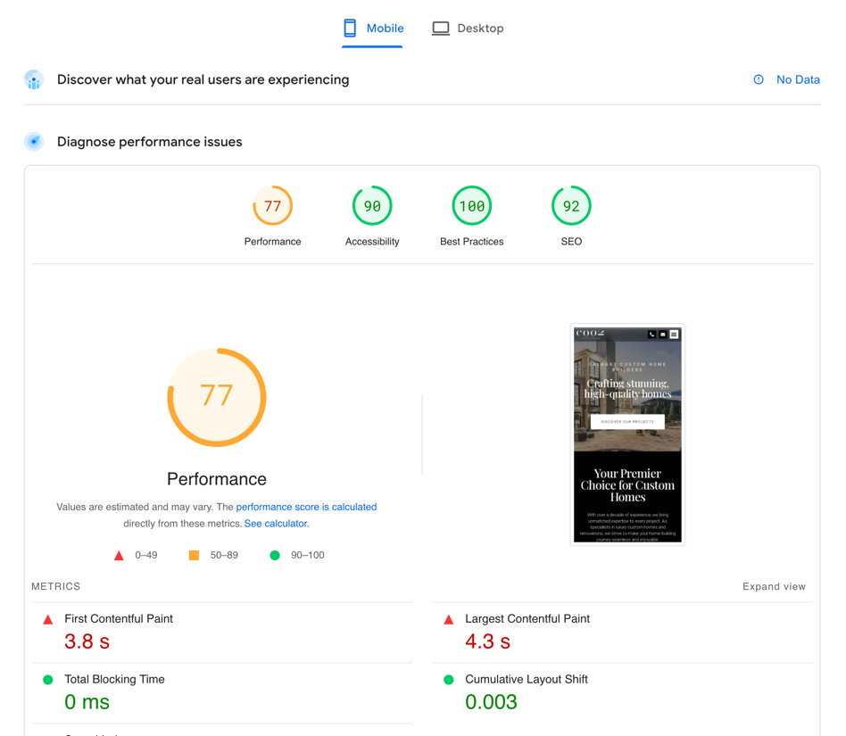

Plugin installation

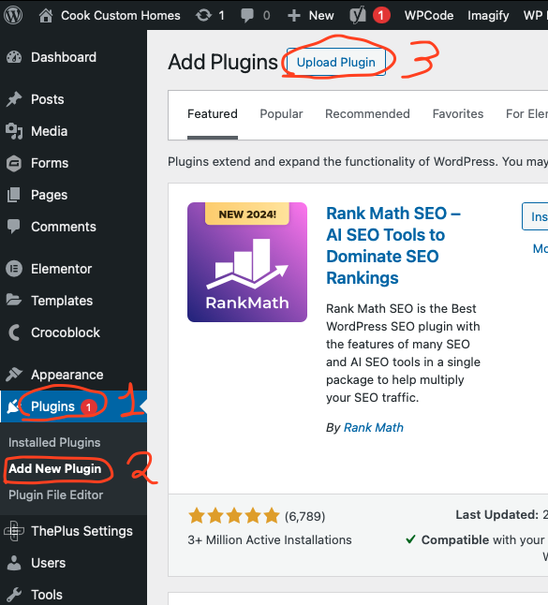

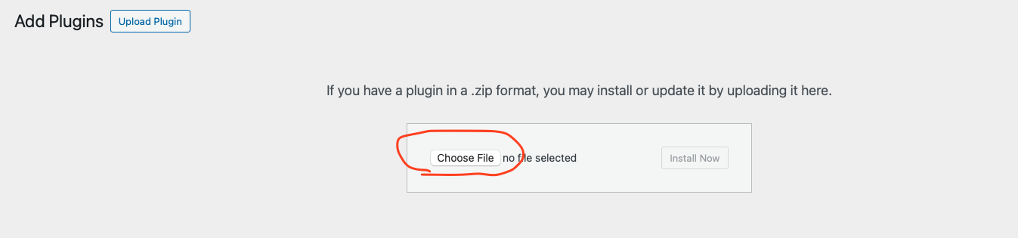

Choose a file with the plugin, hit the ‘Install now’ button



and then Activate it

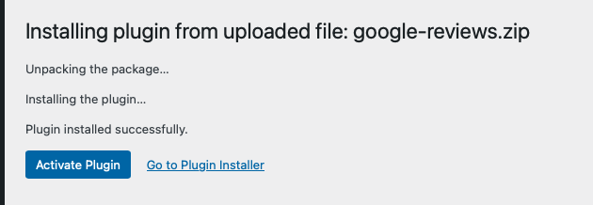

Go to page edit with Elementor. Typing in the search ‘Google’ and you can use a widget

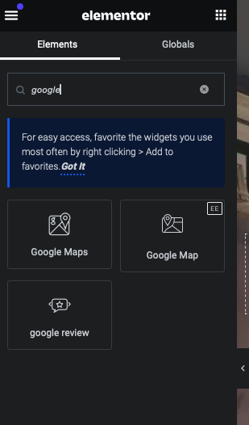 and adjust all options inside the widget 